Opening Scene:.  Narration: Today, we're going to make a refreshing cocktail perfect for a hot summer day, a strawberry margarita.  Motion: The camera shows a close-up of a blender filled with ice  Accessibility Tool: Closed captioning is available for those who may have difficulty hearing the narration and audio descriptions are available for those who may have difficulty seeing the camera motion. | 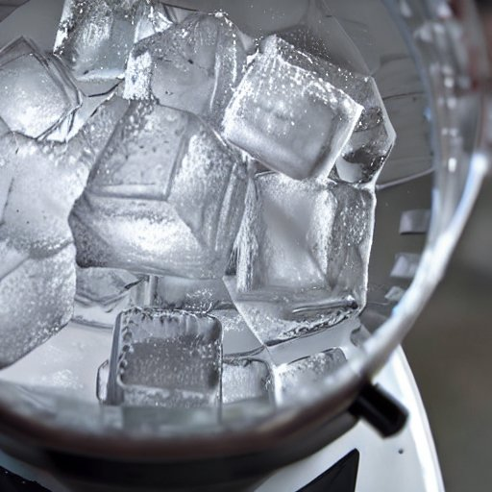
Scene 2:.  Narration: First we need two ounces of tequila  Motion: The camera zooms in on a bottle of tequila  Accessibility Tool: Closed captioning is available for those who may have difficulty hearing the narration and audio descriptions are available for those who may have difficulty seeing the camera motion. | 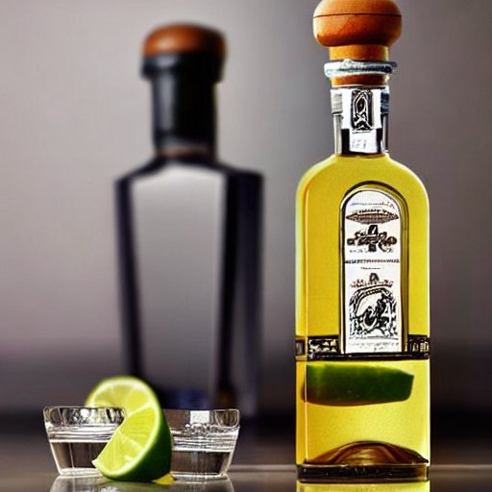
Scene 3:  Narration: We will add a handful of fresh strawberries to the blender  Motion: The camera moves to show a bowl of fresh strawberries  Accessibility Tool: Closed captioning is available for those who may have difficulty hearing the narration and audio descriptions are available for those who may have difficulty seeing the camera motion. | 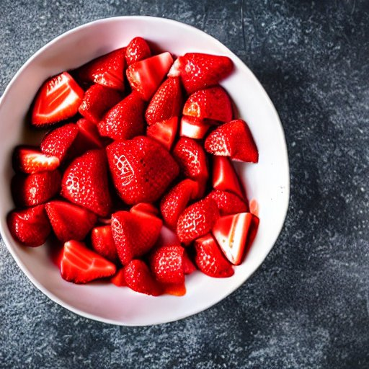
Scene 4:  Narration: Next is one ounce of triple sec  Motion: The camera moves with the liquid, as triple sec is being poured into the blender  Accessibility Tool: Closed captioning is available for those who may have difficulty hearing the narration and audio descriptions are available for those who may have difficulty seeing the camera motion. | 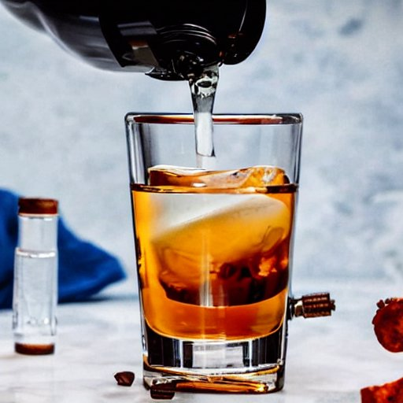
Scene 5:  Narration: Squeeze the juice of one lime into the blender  Motion: The camera moves to show a lime being squeezed.  Accessibility Tool: Closed captioning is available for those who may have difficulty hearing the narration and audio descriptions are available for those who may have difficulty seeing the camera motion. | 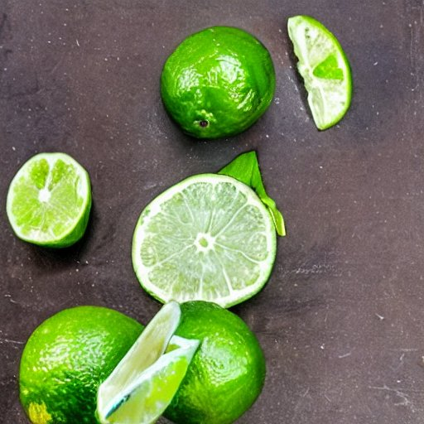
Scene 6:  Narration: Finally, add one ounce of agave nectar to the blender.  Motion: The camera shows a bottle of agave nectar being added to the blender.  Accessibility Tool: Closed captioning is available for those who may have difficulty hearing the narration and audio descriptions are available for those who may have difficulty seeing the camera motion. | 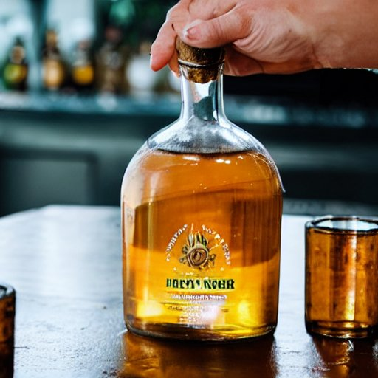
Scene 7:  Narration: Blend the ingredients until smooth.  Motion: The camera shows the bartender blending the ingredients.  Accessibility Tool: Closed captioning is available for those who may have difficulty hearing the narration and audio descriptions are available for those who may have difficulty seeing the camera motion. | 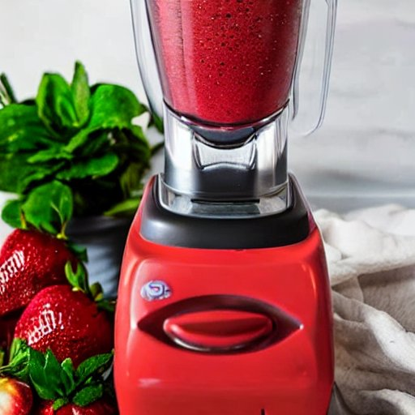
Scene 8:  Narration: Rim a glass with salt.  Motion: The camera moves to show a glass being rimmed with salt.  Accessibility Tool: Closed captioning is available for those who may have difficulty hearing the narration and audio descriptions are available for those who may have difficulty seeing the camera motion. | 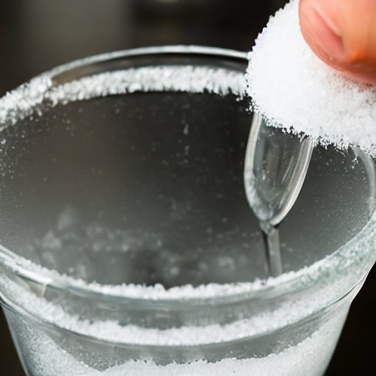
Scene 9:  Narration: Pour the margarita into the glass.  Motion: The camera moves back to the blender, showing the bartender pouring the margarita into the glass.  Accessibility Tool: Closed captioning is available for those who may have difficulty hearing the narration and audio descriptions are available for those who may have difficulty seeing the camera motion. | 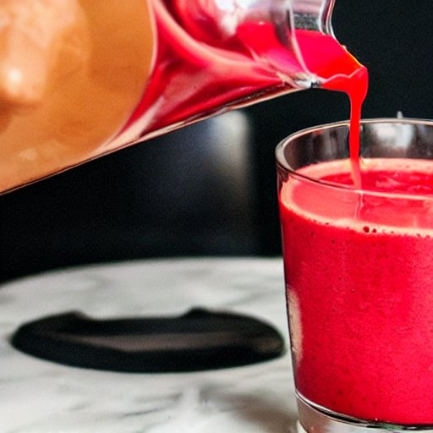
Scene 10:  Narration: Garnish with a sliced strawberry.  Motion: The camera shows a sliced strawberry being added to the top of the margarita.  Accessibility Tool: Closed captioning is available for those who may have difficulty hearing the narration and audio descriptions are available for those who may have difficulty seeing the camera motion. | 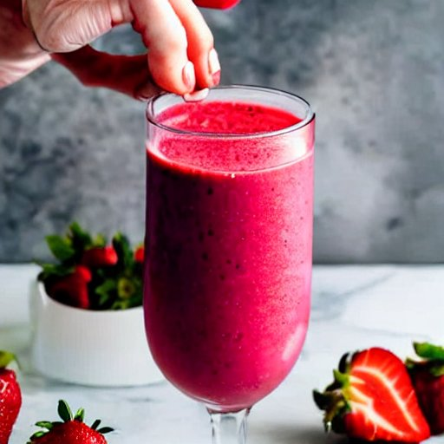
Scene 11:  Narration: And there you have it, a delicious strawberry margarita to enjoy!  Motion: The camera moves to show the finished margarita in all its glory.  Accessibility Tool: Closed captioning is available for those who may have difficulty hearing the narration and audio descriptions are available for those who may have difficulty seeing the camera motion. | 